Curious Caterpillars Supply list School Year 2025/26
Item | Amount and Description | Example  No need to stick to the brands displayed, any will work
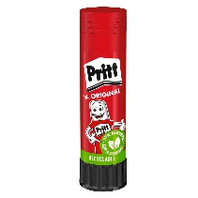 | 5 x 10g glue sticks | Glue Stick Pritt 10g - Glue sticks - Charlot
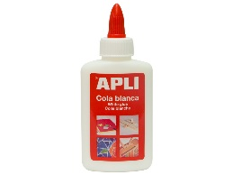 | 2x 100g liquid white glue | White Glue Forpus PVA 120g - White glue - Charlot
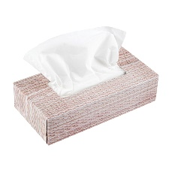 | 2x Tissue boxes | Salvrätikud Box Ultra Soft, 3-kihiline, KLEENEX, 72 tk - Hügieenilised salvrätikud, vatid - Näohooldus - Enesehooldustarbed
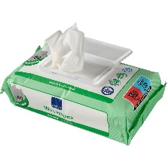 | 1x Wet wipes | Niisked lapid Wet Wipes 72tk, HELEN HARPER, 72 tk - Beebi hooldusvahendid - Lastekaubad
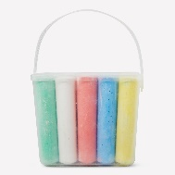 | 1 small Chalk box | Street marking crayons 6x EberhardFaber - Chalks - Charlot
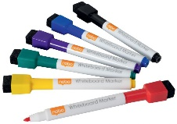 | 1 set of whiteboard markers | Tahvlimarkerid REXEL/ NOBO Quartet Mini , 6 tk. komplektis, peenike, magneti ja kustutajaga
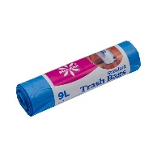 | 1 roll of 10L trash bags | Prügikott 9l, 310x380, MCLEAN, 50tk/rull - Prügikotid, tolmukotid - Puhastus-ja koristusvahendid - Majapidamis- ja kodukaubad
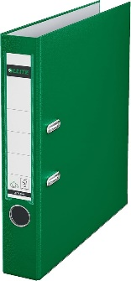 | 1x Green A4 Binder (2 Ring) | https://www.amazon.com/Leitz-Premium-Textured-European-1010-GR/dp/B000KJIA8U?th=1

