**SUPPLY LIST for 2025/2026 SCHOOL YEAR **

**N2 Playful Pandas**

* **Portfolio folder BLACK or WHITE**

***Example: A4 75mm***

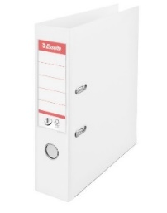 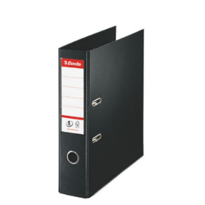

<https://www.byroomaailm.ee/catalog/product/view/id/5433/s/registraator-a4-75mm-valge-esselte-no-1-power-pp-vivida/?sku=K0009134>

<https://www.byroomaailm.ee/catalog/product/view/id/5521/s/registraator-a4-75mm-must-esselte-no-1-power-pp/?sku=K0009288>

* **Cardboard folder A3**

***Example:***

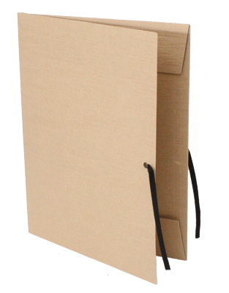 <https://www.byroomaailm.ee/en/cardboard-folder-a3-with-ribbons-cork?sku=K0009699>

* **5 Glue sticks 20gr**

***Example***:

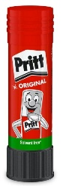 <https://www.byroomaailm.ee/kampaaniad/liimipulk-pritt-20g> or

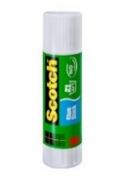 <https://www.byroomaailm.ee/kampaaniad/liimipulk-scotch-21g-t6221d>

* **Paper block for art (painting) A4**

***Example:***

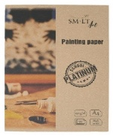 <https://www.byroomaailm.ee/joonistuspaber-a4-250g-m2-20lehte-kmpl-platinum-smlt?sku=K0074265>

* **Paper block for art (painting) A3**

***Example:***

<https://www.byroomaailm.ee/catalogsearch/result/?q=A3+joonistuspaber>

* **Regular pencil**

***Example:*** 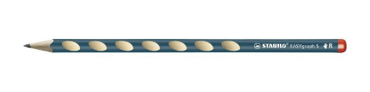

<https://www.byroomaailm.ee/catalogsearch/result/?q=stabilo+easygraph+pliiats>

* **Colour pencil**

***Example:*** 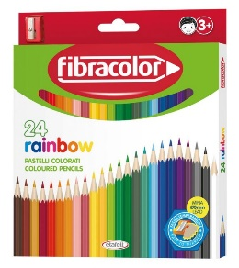

<https://www.byroomaailm.ee/catalogsearch/result/?q=v%C3%A4rvipliiats> 

* **2 Tissue box**

