* **Writing pencils** x 6 (named)
* **Colouring pencils** x 2 pack (named)
* **Coloured markers** x 1 pack (named)
* **Glue Stick** x 3 (named)
* **Scissors** x 1 (named)
* **Erasers** x 4 (named)
* **Small Ruler** x 1 (named)
* **Pencil Sharpener with container** x 1 (named)
* **Whiteboard markers** x 4 (named)

The items below should be inside a well-organised pencil case such as this one in the picture (spares will be kept in their class cubbie):



* **Zip up folders A4 size** x 2 (named): One as a homework folder and one for loose papers

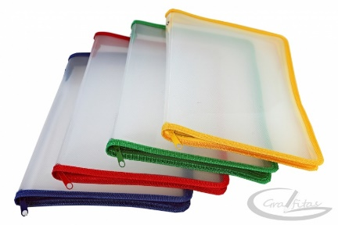

* **A5 lined notebook x 2** (softcover, not spiral) for spelling homework (named)
* **A4 lined notebook** x1 (softcover, not spiral) for English (named)
* **A4 squared notebook** x1 (softcover, not spiral) for Maths (named)